Tutorial - Creating your first experiment using the toolkit

## Overview

This tutorial will guide you through the basic steps to make a simple experiment. For this tutorial our experiment will present the participant with a simple stimulus, and then have the participant match the size of another object to the stimulus. We will vary the stimulus’ size, and distance, and the color of the stimulus. We will also collect participant’s age and assign them an ID. We want to record how close the participant matched the size, and the time it took them.

## Requirements:

* Basic knowledge of C#
* Basic knowledge of Unity
  + Know how to do basic scripting, MonoBehaviours, GameObjects, Scene construction, etc.
* This is written for Visual Studio 2017, Unity 2019.1
* Have the Visual Studio Unity Tools extension installed.
* [Highly recommended] Using JetBrains Resharper Plugin for Visual Studio. Resharper also has its own Unity Extension for unity-specific help. It makes your coding life way easier and saves a ton of time. It keeps your code clean and suggests changes/problems that may come up.

## Set up the project:

1. Create a new Unity Project
2. Go to Edit > Project Settings > Player:
   1. Change the Api Compatibility Level to .Net 4.0
   2. Change the Scripting Runtime Version to .Net 4.x Equivalent
3. Download the latest release of BML_ExperimentToolkit from NEED LINK
4. Import the .unitypackage in the downloaded folder:
   1. In Unity, go to Assets > Import Package > Custom Package and browse to the .unitypackage.
   2. Click Import all

## Set up our Experiment Scene

1. Create a folder for your experiment files:
   1. In the project navigator window, right click your assets folder, and select Create > Folder
      1. Name it TutorialExperiment
2. Create a new Unity Scene inside the folder and name it TutorialExperiment
3. Create an Experiment GameObject
   1. In the new scene, create an Empty GameObject, and name it Experiment.
4. This GameObject needs to have a custom ExperimentRunner Script attached to it. We will need to create this script, and then drag it onto our Experiment GameObject. This is the main window of communication between the toolkit and your unity scene.

Create Custom ExperimentRunner for your experiment

1. Inside your TutorialExperiment Folder, right click and create a new C# script
   1. Right click on Assets > TutorialExperiment Folder > Create > C# script
   2. Name it TutorialExperimentRunner.
   3. Double click on the created file
2. The file will load in VisualStudio and unity has already populated it with some code.
   1. Delete the Start and Update methods.
   2. The script automatically inherits from the MonoBehaviour class. However, we want it to inherit from ExperimentRunner.
   3. Replace the word MonoBehaviour with ExperimentRunner.
   4. This makes our script “an ExperimentRunner”, to which we can add custom functionality for our experiment’s needs.
   5. Visual studio should automatically import the correct namespace
   6. If you don’t have VisualStudio set up properly, you may get an error or see ExperimentRunner underlined in red. To fix this we need to import the correct namespace by typing at the top of the file:

using BML_ExperimentToolkit.Scripts.ExperimentParts;

* 1. Your file should look like this:

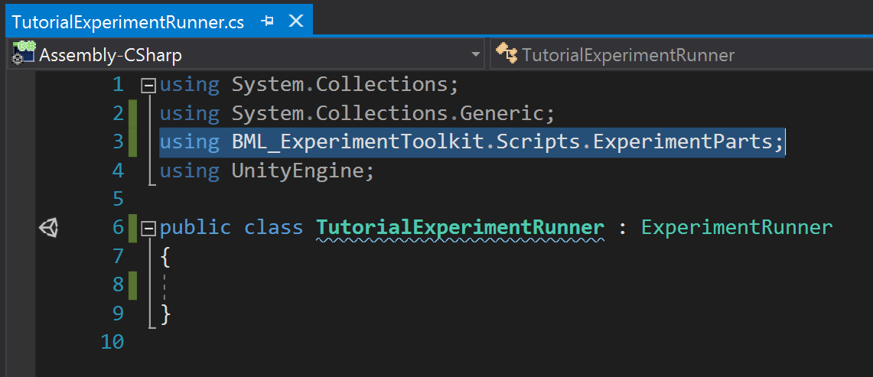

1. Now we can drag this script onto our Experiment GameObject in the scene.
2. Click on the Experiment GameObject. Notice how in the inspector, the script appears, and is automatically asking for a Config File. We need to configure our experimental design, and reference it here.
3. Let’s create our config file

## Configuring the experimental design

The toolkit comes with a powerful system for setting up your experimental design. We need to define it using a config file.

1. Create a new config file. The toolkit adds a custom menu to the asset creation context menu which allows you to create assets necessary to define the functionality and customization for your experiment.
   1. Right click the TutorialExperiment Folder and choose
      1. Create > BML Assets > Variable Configuration
      2. This creates a new asset.
      3. Name it TutorialConfig.
2. Clicking on our config file reveals an inspector with several options. For more detail on what these settings do please see the main documentation. Notice how there are sections for different types of variables. Briefly:
   1. Independent variables: any manipulated variables that change between trials or blocks in your experiment (e.g. which stimuli, presentation time, distance from participant etc.)
   2. Dependent variables: outputs or measurements from your experiment (i.e. response time, selection etc.)
   3. Participant variables: Collected at the start of the session from each participant (e.g. gender, ID, etc.)
3. Let’s set up our experiment’s variables.
4. We want to vary the color of the experiment in each trial. So let’s define it as an independent variable named Color.
   1. In the config file’s inspector, in the Variable Creation section, under type to create, choose “String” to make a text-based data variable.
   2. Select Independent.
   3. Click Create Variable
      1. You should see a new variable appear in the Independent Variables section.
      2. We want to vary color every trial, so keep Block unchecked.
      3. We want an the same number of trials of each color, so choose Balanced for the mixing type.
   4. Define values for our variable. Click the plus button to add a values
      1. Add values Red, Blue, Green.
   5. You should see something like this:

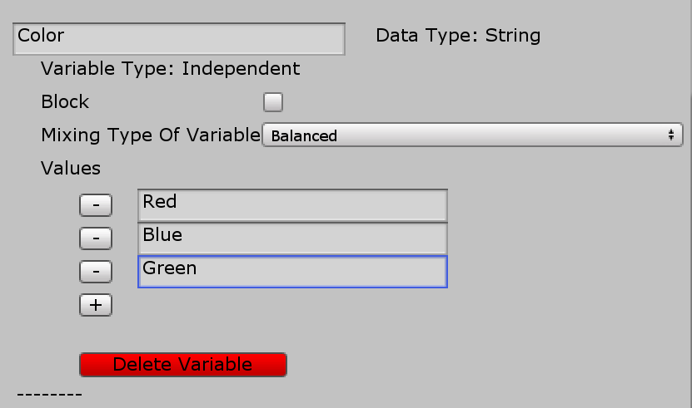

* 1. Let’s create our Distance variable. In this case we want to do all the trials at one distance, and then do all the trials at another distance. So in this case we want to distance to be a blocked variable.
     1. Create a float independent variable.
     2. Name it Distance
     3. Check block
     4. Choose balanced
     5. Add values 1,2,3
  2. Let’s create our size variable. This one will be more complicated. Each trial we want it to randomly select a size from a list of values, but we want the size of 2 to appear in half of all trials. We can do this using the custom probability mixing type.
     1. Create a float independent variable
     2. Name it Size
     3. Uncheck Block
     4. Choose custom probability
     5. Add values 1, 1.5, 2.
     6. To define the propabilties, we want the other two options to each be 0.25. So we type them in, and the toolkit will automatically fill in 0.5 probability for the value of 2. Ensure that the Total probability is 1.
  3. We want to record the participants gender and age.
     1. Create a String Participant variable named Gender
        1. Check Constrain values. This ensures that the value is restricted to a set of values that we define.
        2. Type in Male, Female, Other
     2. Create an int Participant variable named Age.
        1. Keep Constrain values unchecked so we can type in their age.
  4. We want to record how closely the participants match the size of the stimulus. We’ll record that in a float dependent variable called SelectedSize. The default value will be assigned to any missing values in case of problems or stopping the experiment early.

1. Finally, we want to randomize the trial order completely.
   1. In the top of the config file
      1. Check Shuffle Trial Order
      2. Check Shuffle Differently For Each Block
      3. We don’t want to repeat anything so leave Repeat empty.
2. We have to tell our ExperimentRunner GameObject where to find the config file.
   1. Click on the GameObject, and then drag the config file into the appropriate field in the inspector.

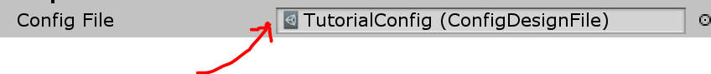

## Test out our experiment design using basic components

The BML toolkit comes with premade parts of experiments already defined to let you get up and started quickly. Lets test out if everything is working as expected before moving forward.

1. Open the BML Menu, and Open the Experiment Runner Window.
2. Press play in the editor. You’ll see the window show some controls.
3. Keep it Debug Mode checked. Debug mode is useful to check functionality during development.
4. Click Confirm Order, which selects the first possible order in which to present the blocks. This order is important when counterbalancing block order between participants.
5. Press Start Experiment.
6. Once Start Experiment is pressed, the toolkit automatically constructs your blocks and trials based on how you defined them in the config file and starts running the first trial
7. Take a look at the experiment table and ensure everything is set up properly. Note that the toolkit adds some useful columns to track progress and other metrics.
8. Because it’s debug mode, our participant variables will not work properly yet. We’ll be able to set values for them later when we leave debug mode.

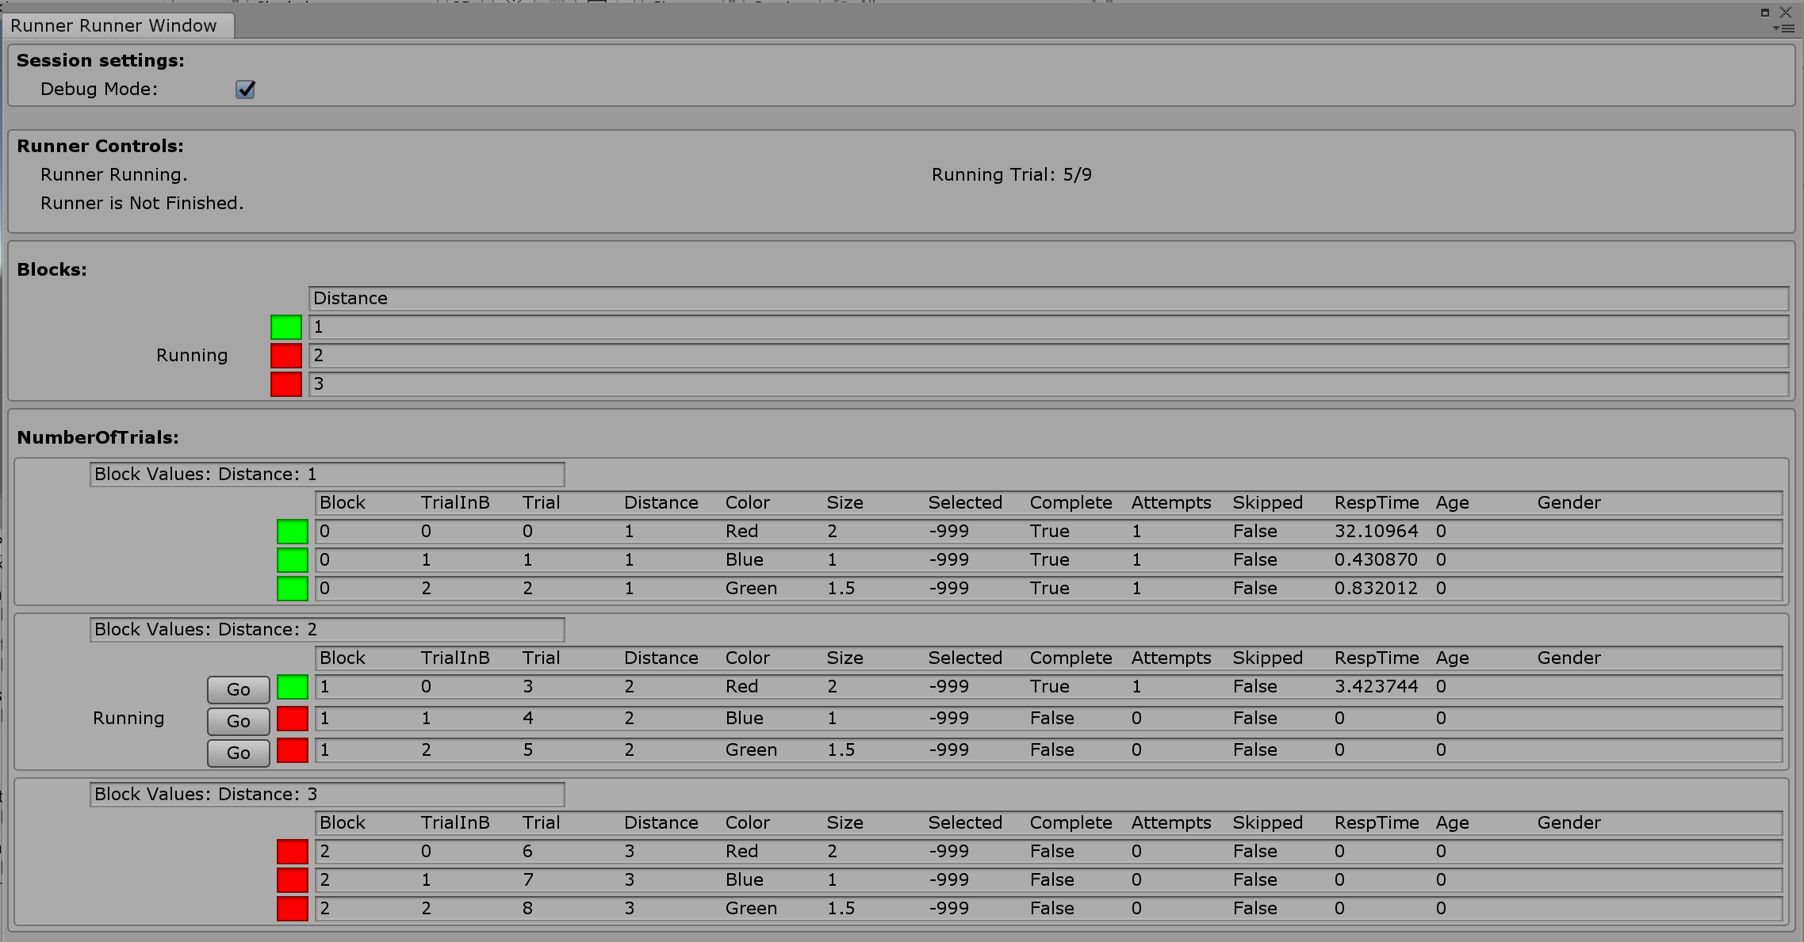

The built-in experiment parts have almost no functionality. A trial is simply defined as pressing the return key. Press it a few times to see how the trials advance, and the values of the independent variables change.

It looks like everything is working properly. Lets move away from the built in experiment parts and define what happens in our experiments’ trial.

## Define what happens in a trial

Now that we have configured the design of our experiment, and set up our experiment runner object, we have to define what occurs in a trial. We need to create a new custom script that inherits from the Trial Class. In our custom Trial script, we define behavior that occurs during each trial based on the values of the independent variables for that trial. Once we’ve defined the trial script we have to edit our custom ExperimentRunner script to tell it that we’re changing the trial from the built-in basic trial to the custom trial script.

1. Create a new C# script in the TutorialExperiment folder and name it TutorialTrial.
2. Open the script in Visual Studio and delete the Update and Start methods.
3. Like before, we don’t want our script to be a basic MonoBehaviour.
   1. We want our TutorialTrial class to inherit from Trial.
   2. Delete MonoBehaviour, replacing it with Trial.
   3. You may need to import the proper namespace again.
      1. Using BML_ExperimentToolkit.Scripts.ExperimentParts;

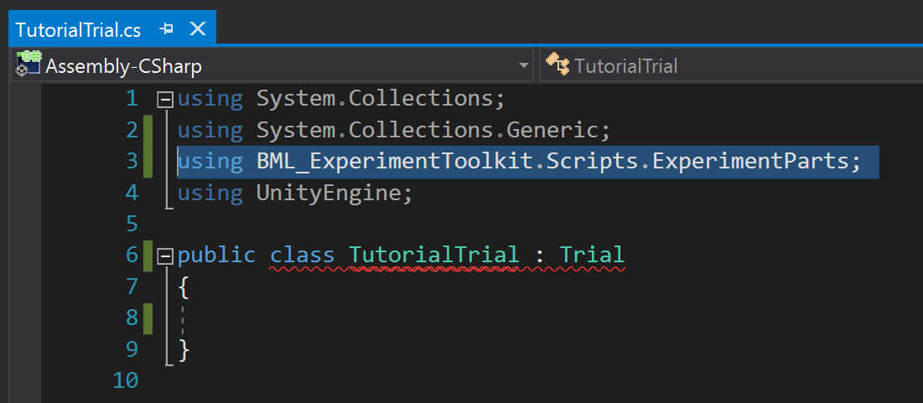

1. Notice how Visual Studio is giving an error underlining our class. This is because the Trial Class forces you to write some methods to make it work with the toolkit. Most editors (including Visual Studio) can solve this easily.
   1. Click on the word TutorialTrial. Visual studio will show a little red lightbulb icon to the left in the margin. Click on the lightbulb and there should be an option similar to “Implement Missing Members”. Select it and some code should appear.
   2. The first part of this is a constructor so that the toolkit can properly create trials when it needs to. This will never need to be changed unless for very advanced customization.
   3. The second part is the important part. This is the main method of our trial in which we define the majority of code that occurs in the trial.
      1. This method is a Coroutine, which means it needs to have at minimum one yield return statement. If you don’t know about coroutines, there is a section in the documentation explaining them.

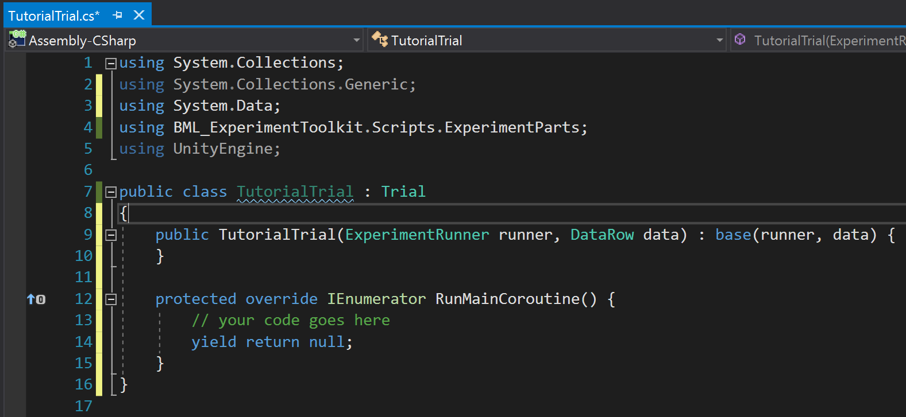

1. Let’s start simple and just have it print something to the console.
   1. Replace the “// your code goes here” with:
      1. Debug.Log(“Trial Running”);
2. Now each trial will simply output that text, and then immediately move on to the next trial.
3. We have to tell the ExperimentRunner to use this custom trial rather than the built-in one.
   1. Open your TutorialExperimentRunner script.
   2. The ExperimentRunner class has a method called TrialType which we can override to point it to our new custom Trial script.
   3. Start typing the word “override”. After a few letters, Visual Studio will show you a popup with some suggestions. Use the arrow keys to scroll down to public override TrialType and hit return. Visual studio will automatically create this method for you.
   4. We want it to point to our TutorialTrial script.
   5. Edit the created method to read:
      1. public override TrialType => typeof(TutorialTrial);
   6. this means that when ExperimentRunner looks for its TrialType it will get the type of trial of your TutorialTrial.

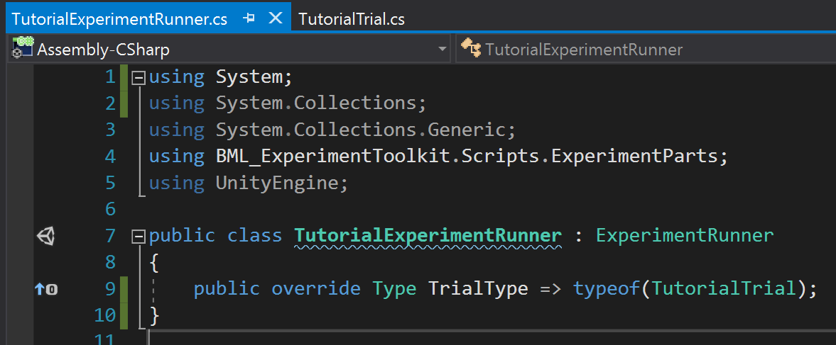

1. Let’s run our experiment from the runner window again to see if it worked. The Trials should all finish one after another. Look in the console to see if it output the correct text. Make sure all the scripts are saved first!

## Setting up the Stimuli

1. Let’s first position our Main Camera to 0,0,0, and have it pointing along the Z axis.
   1. Click the Main Camera in the scene and reset its transform component.
2. Let’s create the object that will be the model to which participants are trying to match.
   1. Create a Capsule GameObject, Name it ModelObject
3. Let’s create the stimulus object
   1. Create a 2nd Capsule GameObject, Name it SimulusObject
4. Now we need a materials to change the stimulus color.
   1. To create material Right-click on folder > Create > Material
   2. Create a 3 materials in the experiment folder, call them RedMaterial, BlueMaterial, GreenMaterial
   3. For each material, in its inspector click the little color next to the albedo, and change it to red/blue/green.

## Referencing GameObjects in your experiment

Now that we’ve set up the objects and materials for our stimuli, we need to be able to reference them in our scripts. We use our experiment runner as our main window to our scene.

1. Open the TutorialExperimentRunner script.
   1. Create public fields for the two capsules and the 3 materials.
   2. It should look like this:

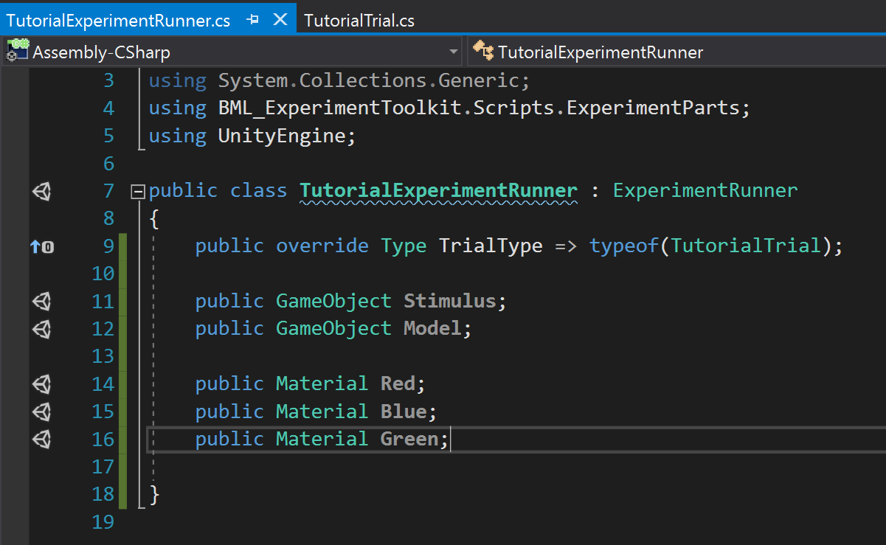

1. In the scene, click on the experiment object,
   1. In the inspector you should see fields now.
   2. Drag the appropriate items into the fields
   3. It should look like this:

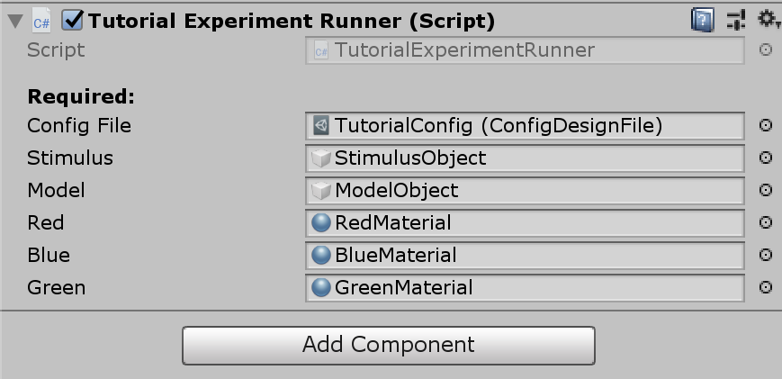

1. Now we need to reference these in our trial script. We could put this code inside our main coroutine method, but this makes more sense in a setup method since it doesn’t happen during the trial, but rather before each trial.
   1. Open the TutorialTrial script.
   2. We want to override the PreMethod method, which is not a coroutine and is used for setting up a trial. It gets automatically called at the start of each trial.
      1. public override void PreMethod() {
   3. Now we need a reference to our custom TutorialExperimentRunner and the objects we defined in it.
   4. Let’s create a field in TutorialTrial to store a reference to it.
   5. The base Trial class already has a reference to it, but it’s not stored as our custom runner but a generic ExperimentRunner. We need to cast it to our custom class TutorialExperimentRunner.
   6. We do the cast in the PreMethod. See the code below.

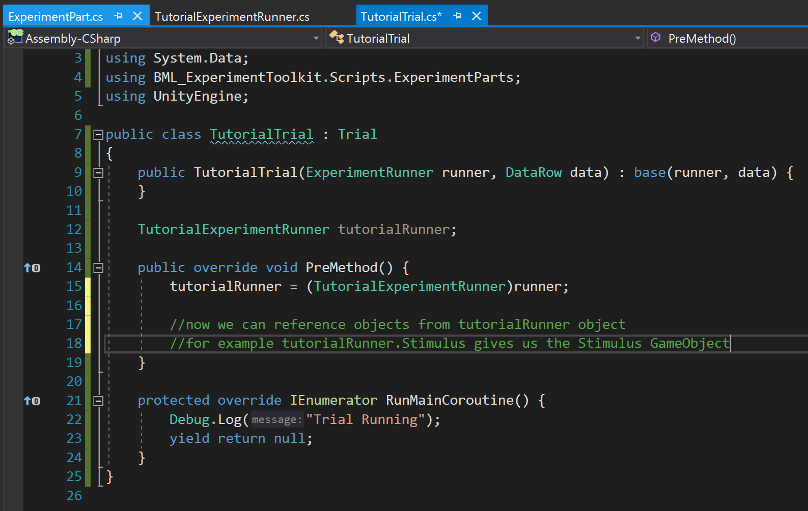

1. Now we can reference our scene’s objects to set them up. But how do we know what size, distance, and color to use? Our Trial object has a Data object that stores the values for each trial. We access our variables stored in this Data object to set up each trial properly. However, remember we defined distance as a block variable. We’ll set that up with our blocks later.
2. Lets set the color first.
   1. We want to access the value for our Color variable for each trial:
      1. string colorString = (string)Data[“Color”];
      2. note the cast to a string. This is necessary to remind C# that your Color variable in the config file is actually a string.
      3. Now we want an if statement to set the stimulus’ material to the correct color. See the code below: